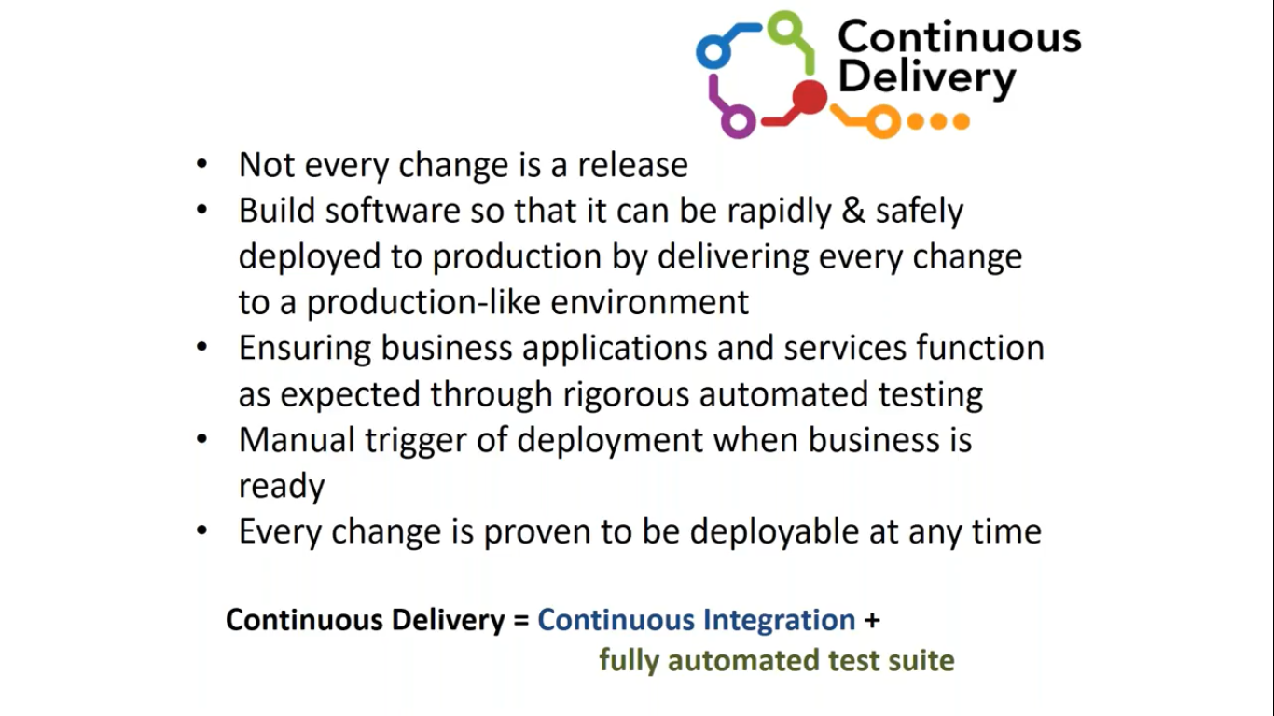

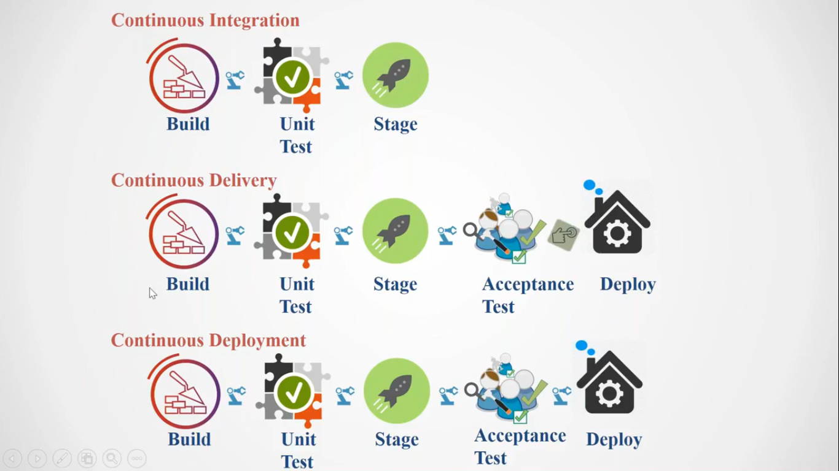

The Basic difference between Continuous Delivery and Continuous Deployment is that if we are able to Build, then do unit on it then store it in a common place and from there if we are able to automate testing also of few functionality then it is called ad Continuous Delivery but it can be deployed Automatically in Production then it is called as Continuous Deployment.

Stage can never be Customer Place it will be in our location only.

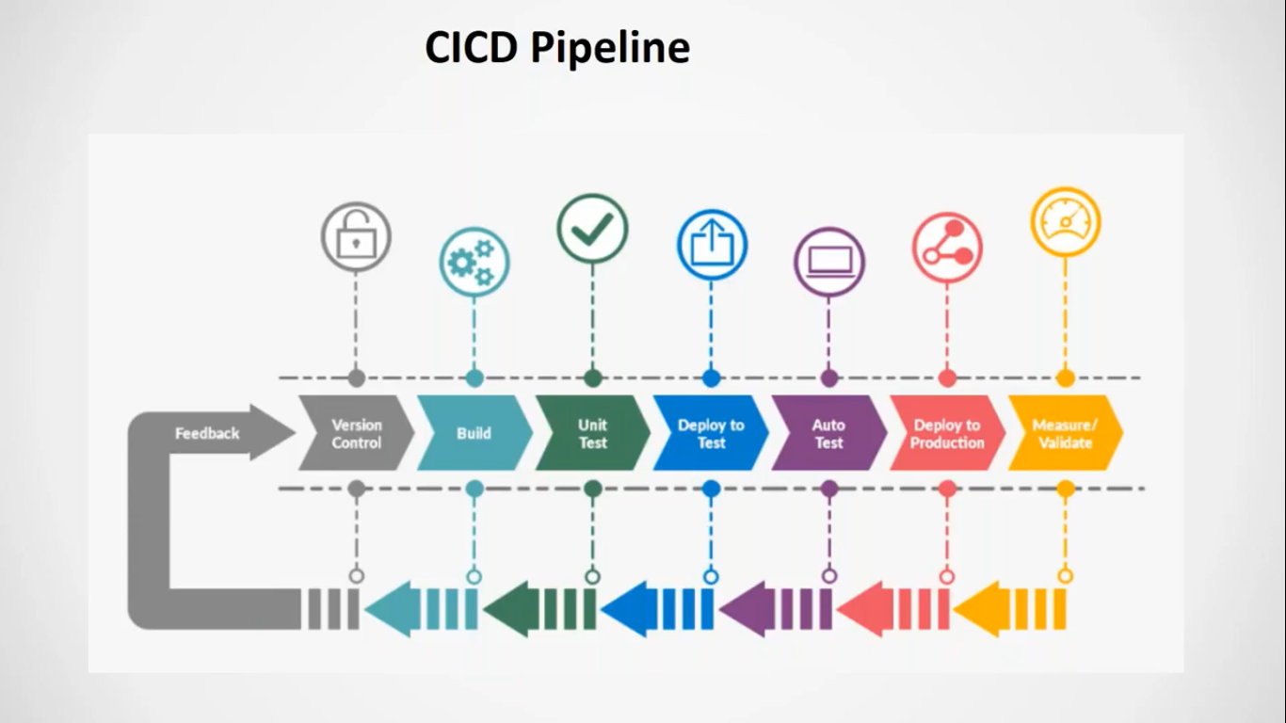

Here If we take free style job there we cannot use the same machine to do all these activities.

It requires different machine at different places and this is possible via pipeline.

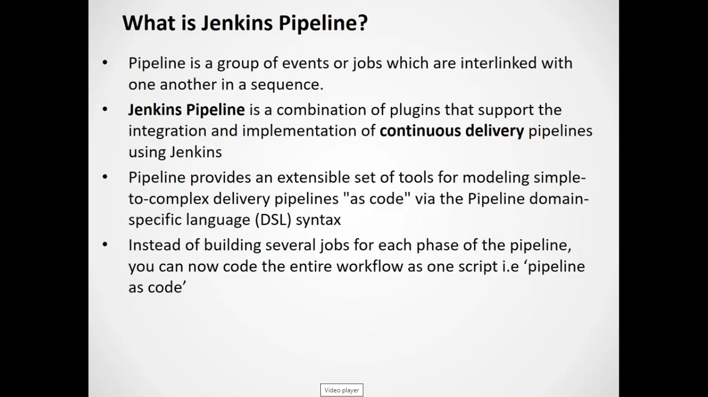

DSL is groovy based language

Jenkins Pipeline is a job which helps in achieving CICD.

It is combination of several jobs in that it will be defined where to do, what to do and when to do via DSL script called as Jenkins file.

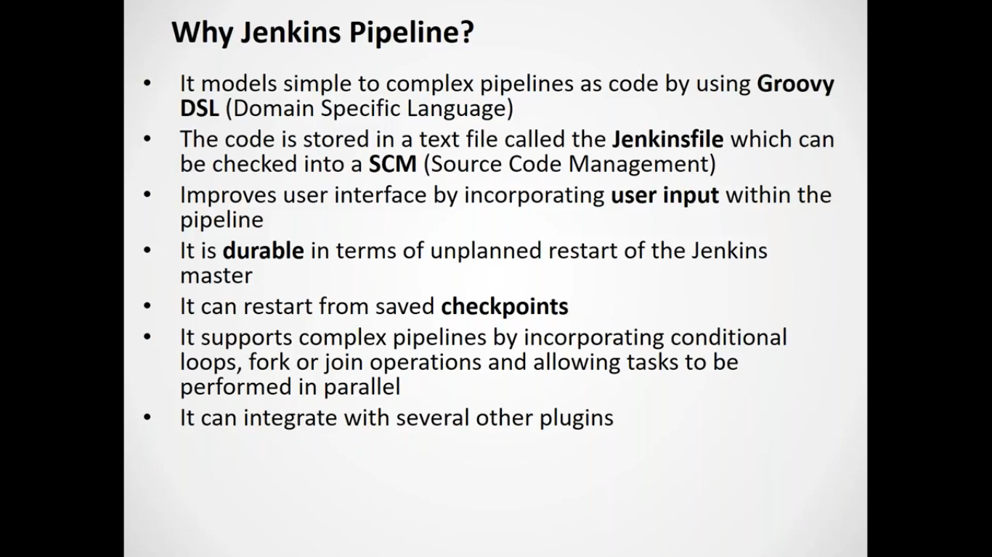

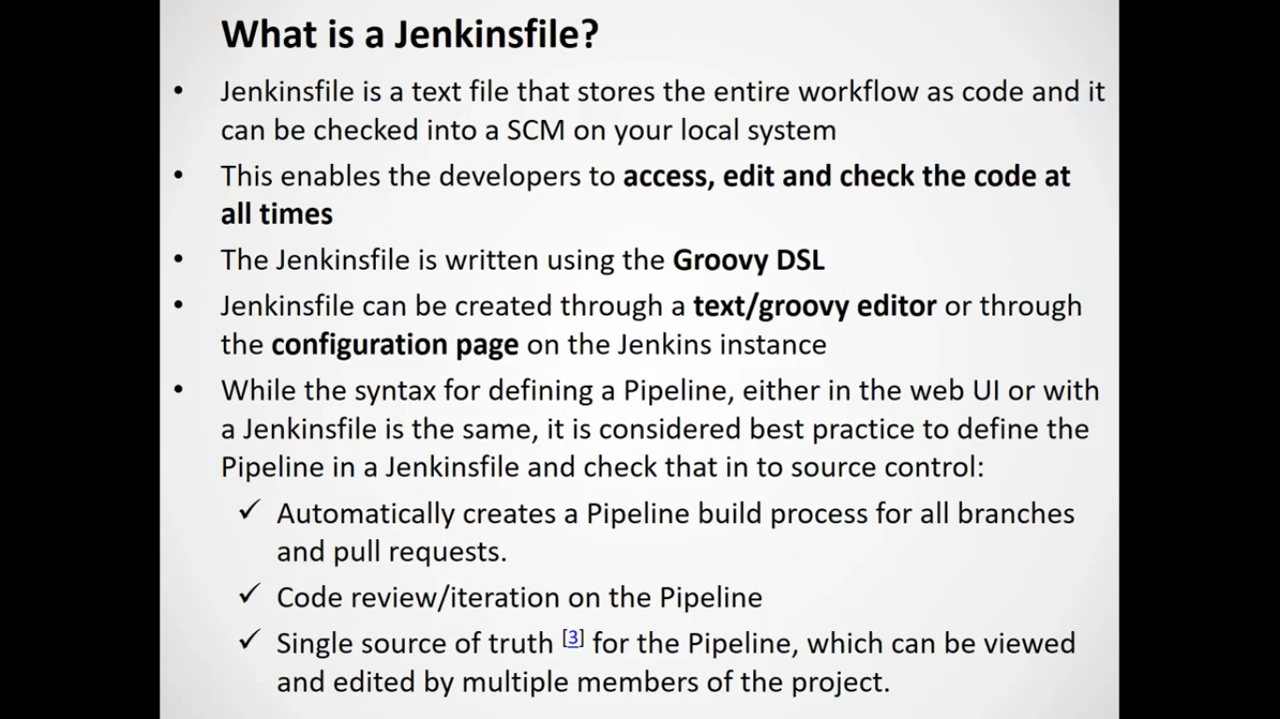

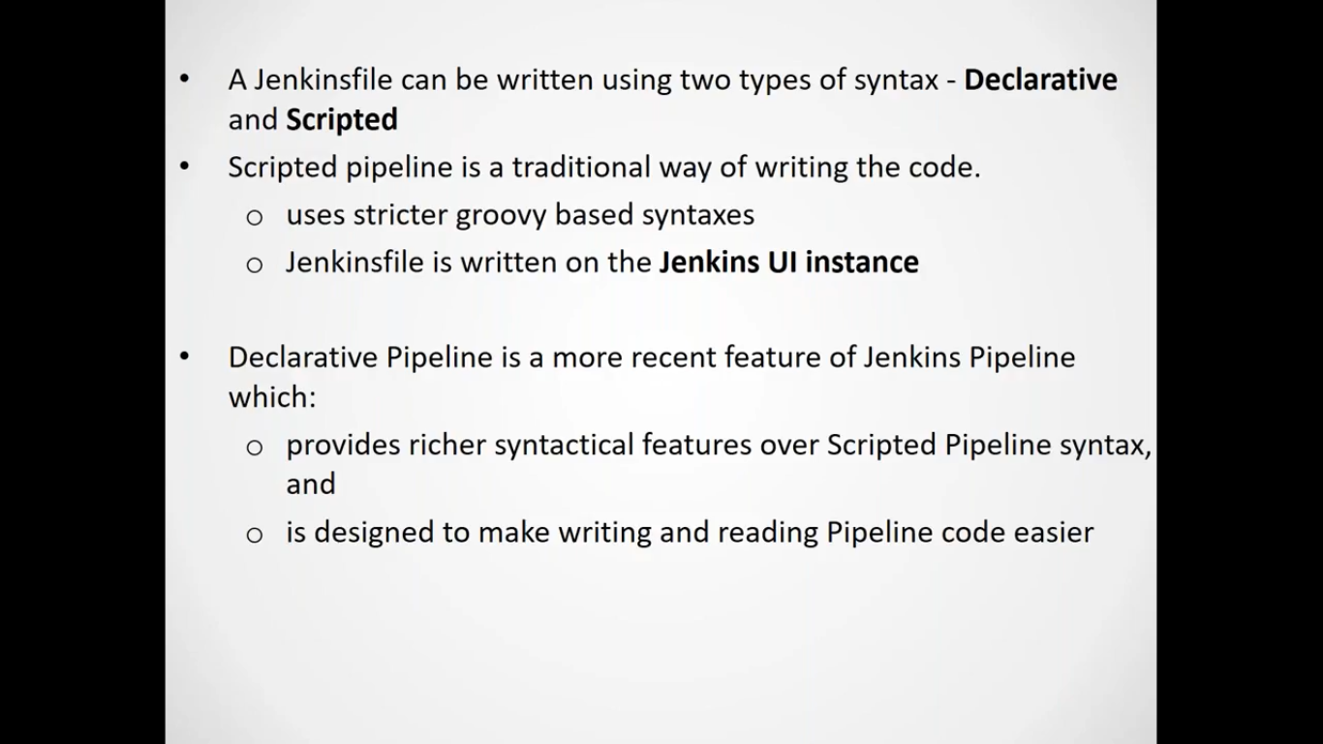

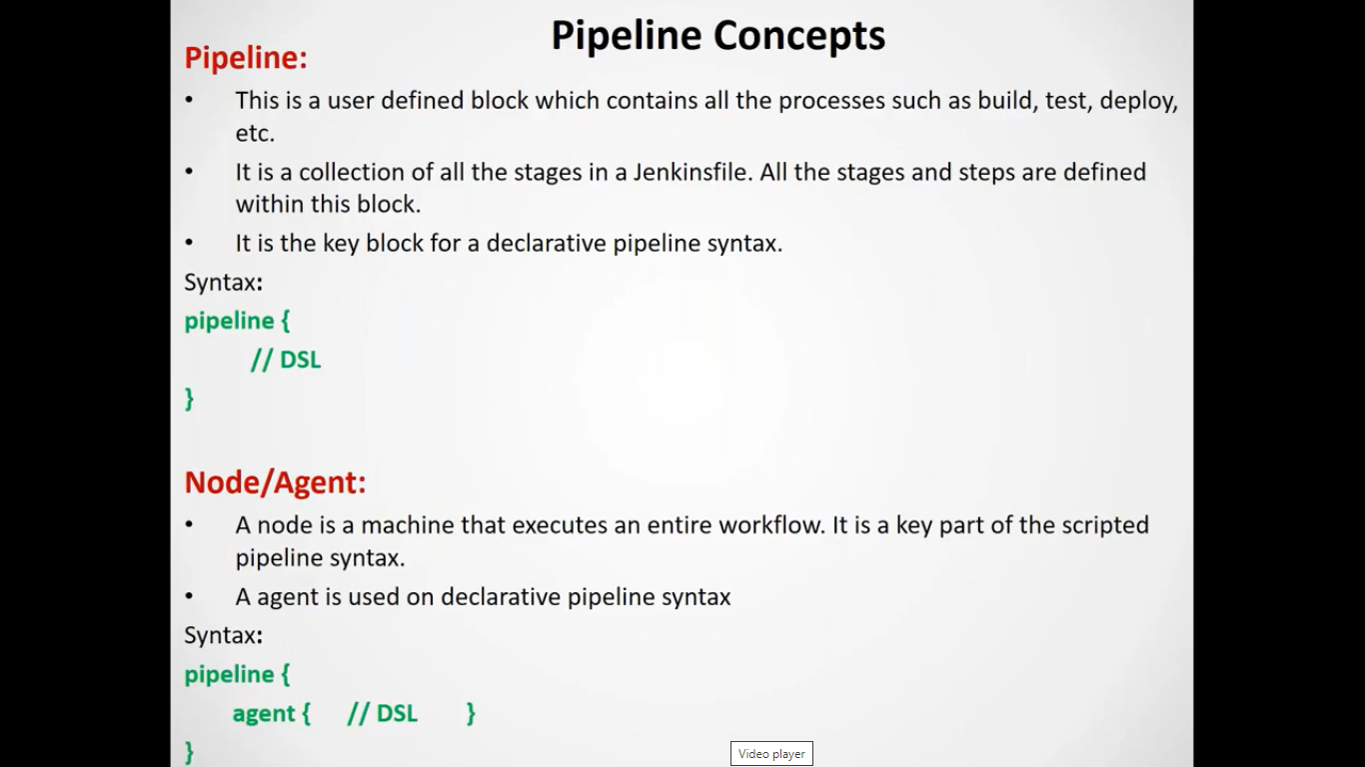

Here everything is composed of block.

Here pipeline block is called as parent block.

All other subblocks will be inside it only

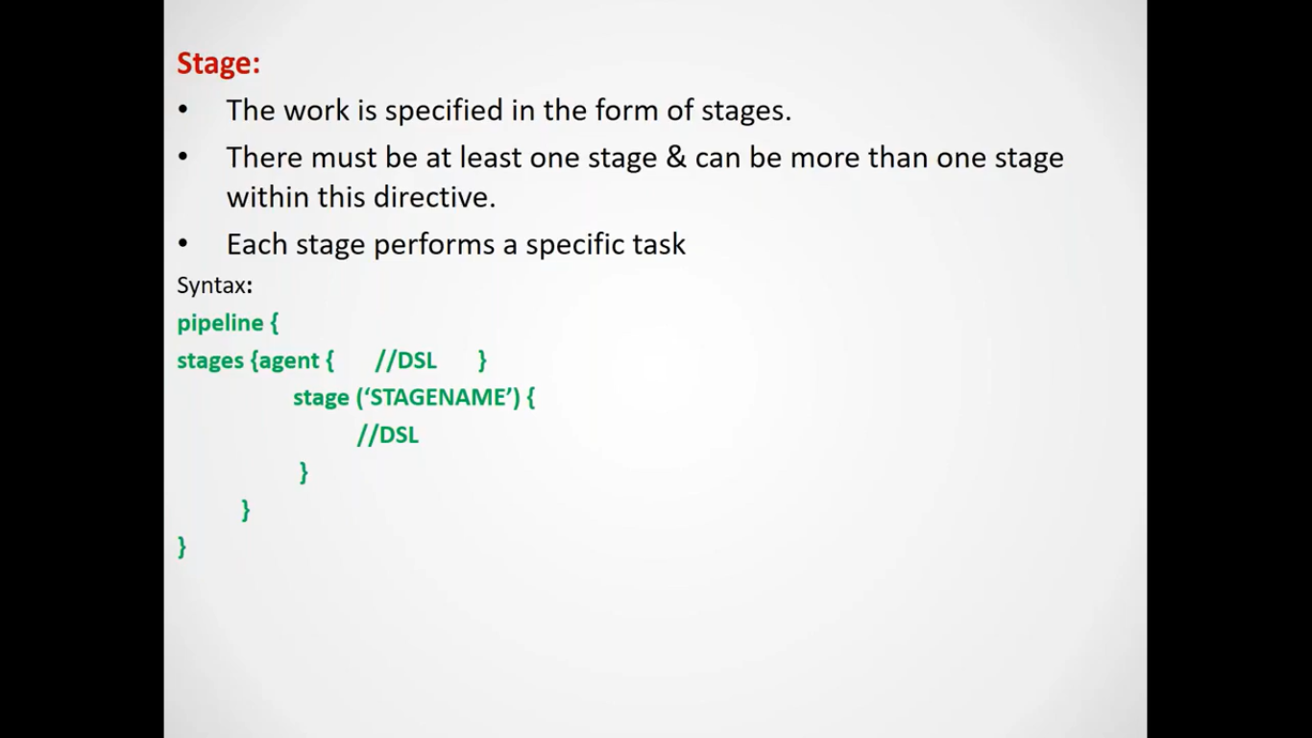

Here stage is nothing but a job i.e. what exactly are you doing.

What to do, when to do and where to do.

One stage is one job

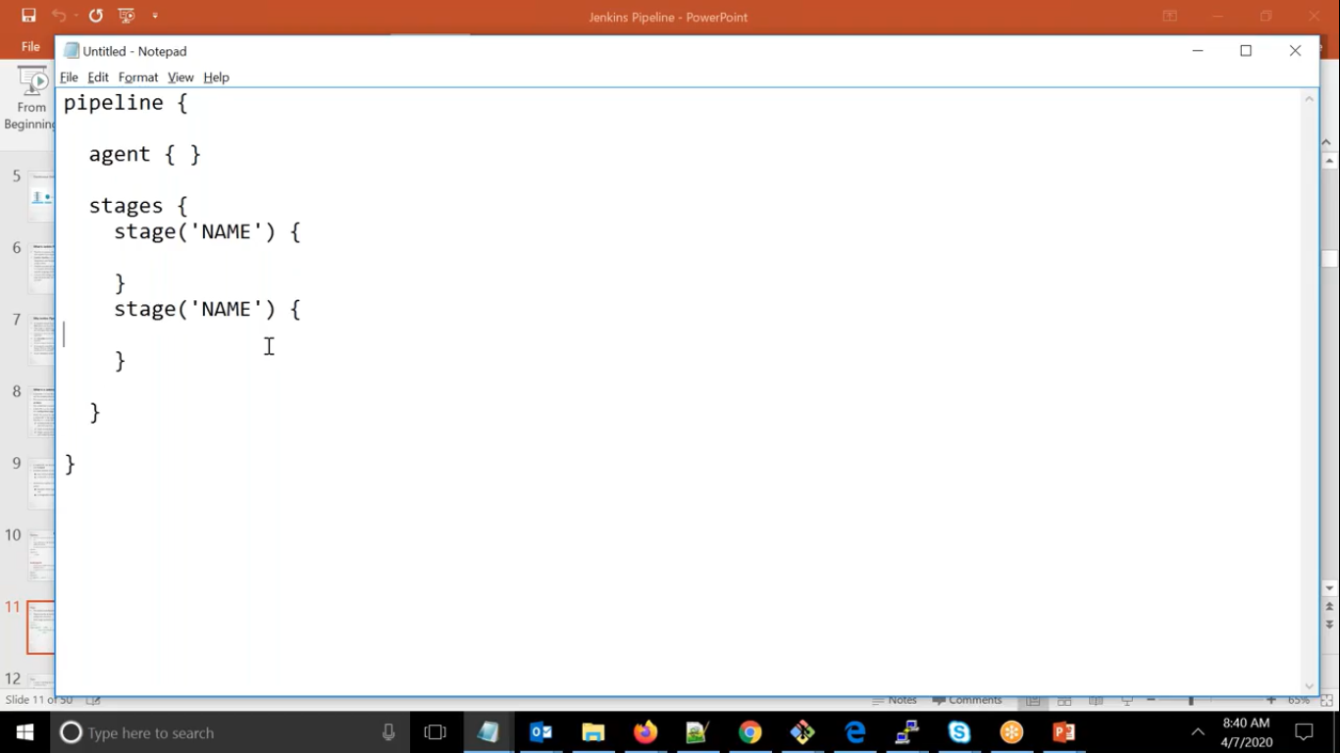

Anything you applied in top level will be applicable for all stages

Like as above, i.e. agent

If you want separate agent for each stages give it like below

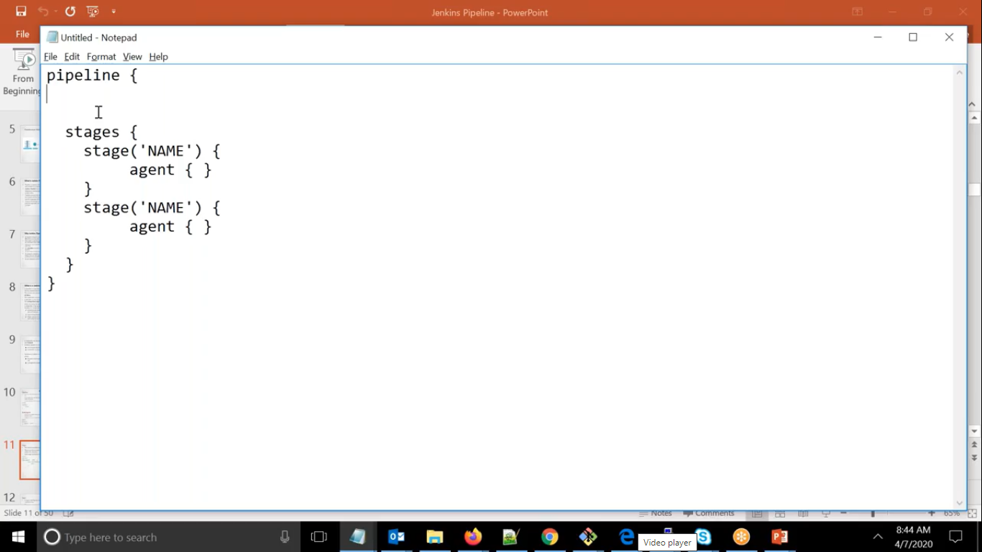

Steps are nothing but these are the task which will tell what needs to do

Like as below

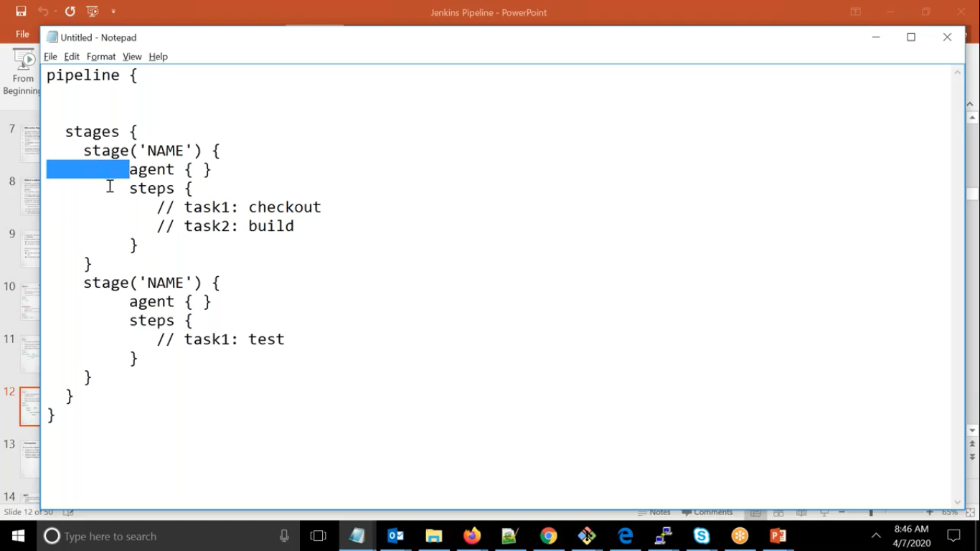

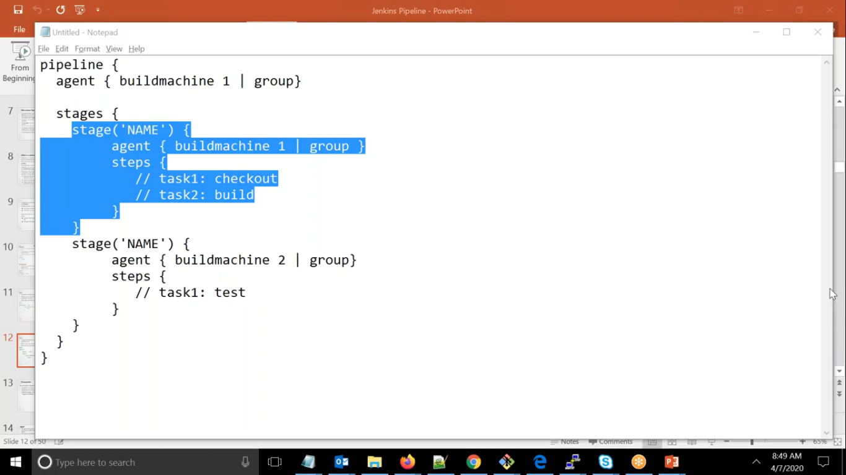

We can give individual machine or we can group

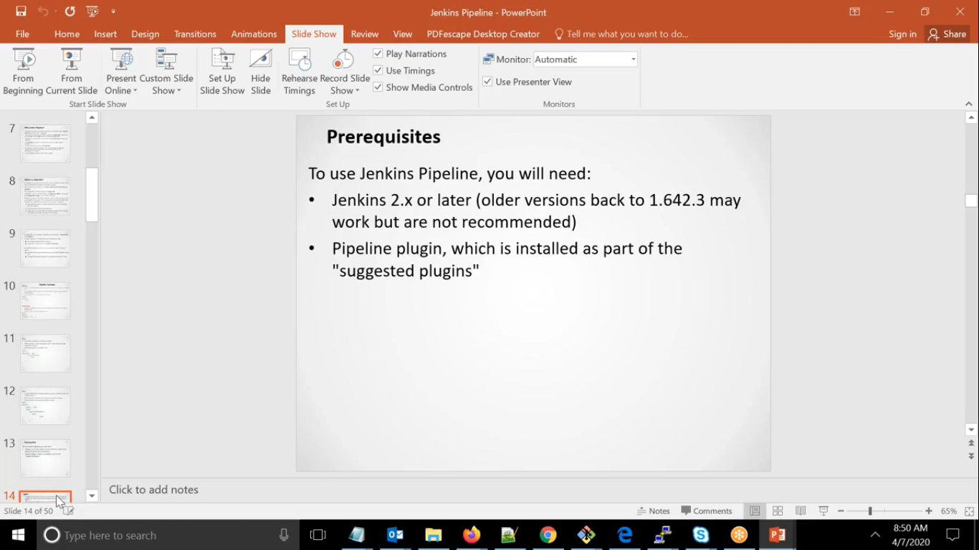

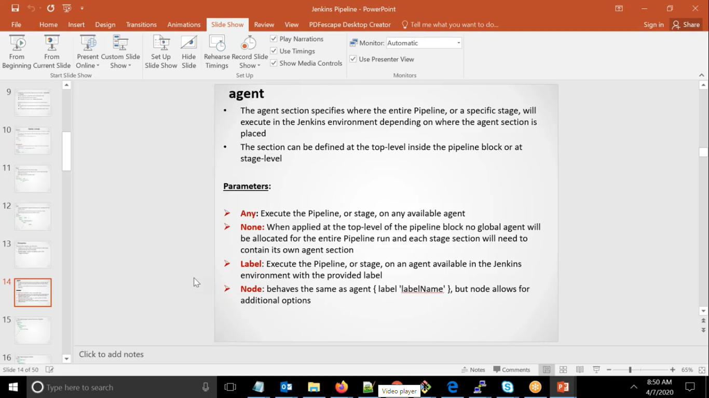

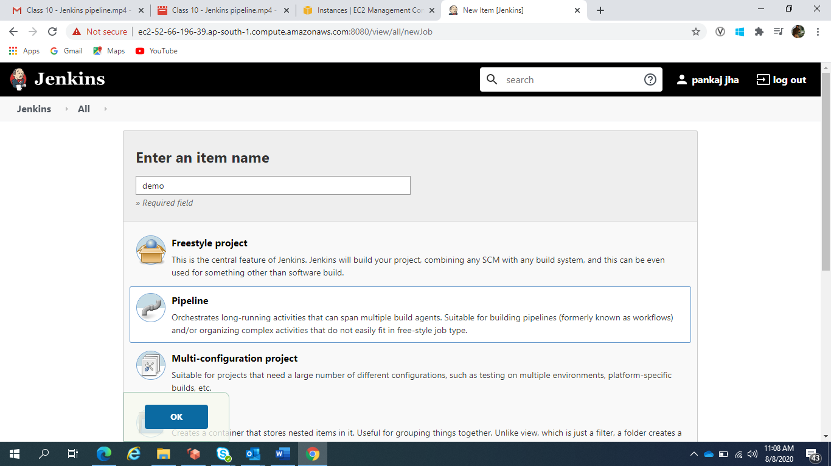

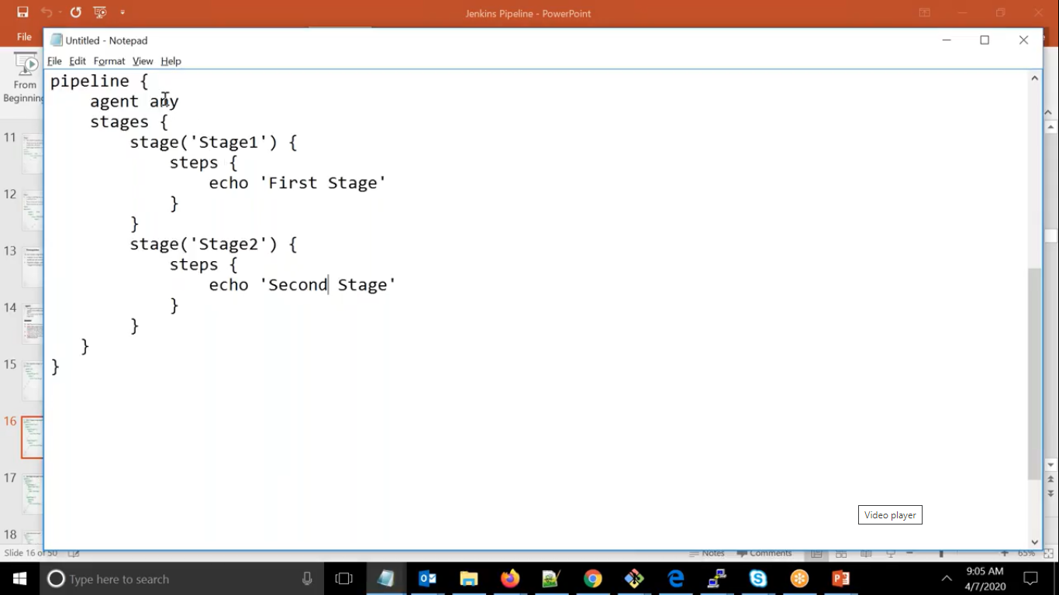

Agent any example as above.

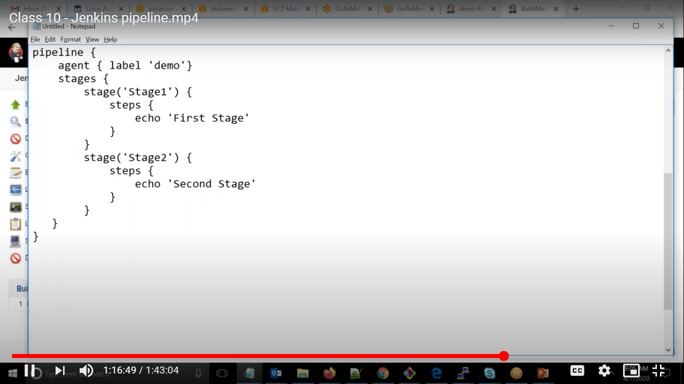

Demo as label, telling to pick any machine available in demo group

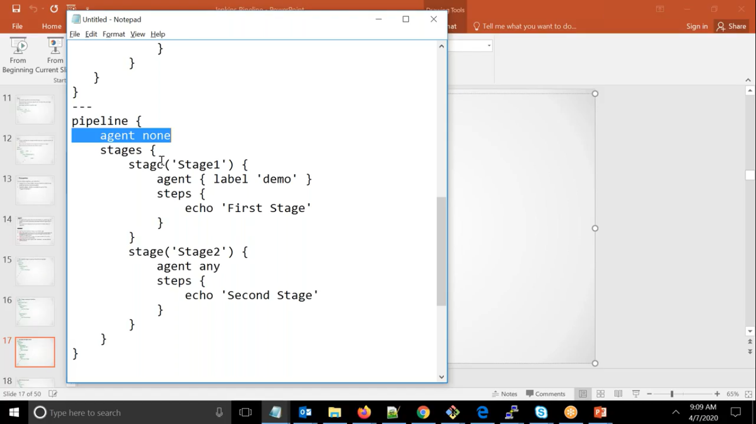

Here each stages but note in top label we have to mention agent as none

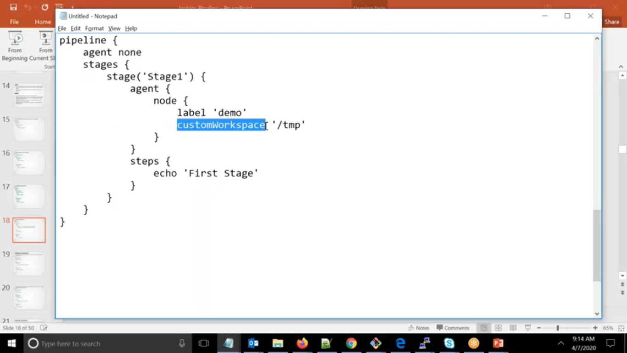

If we want to run on different place i.e. in different workspace.

If you don’t want to run on default remote root directory

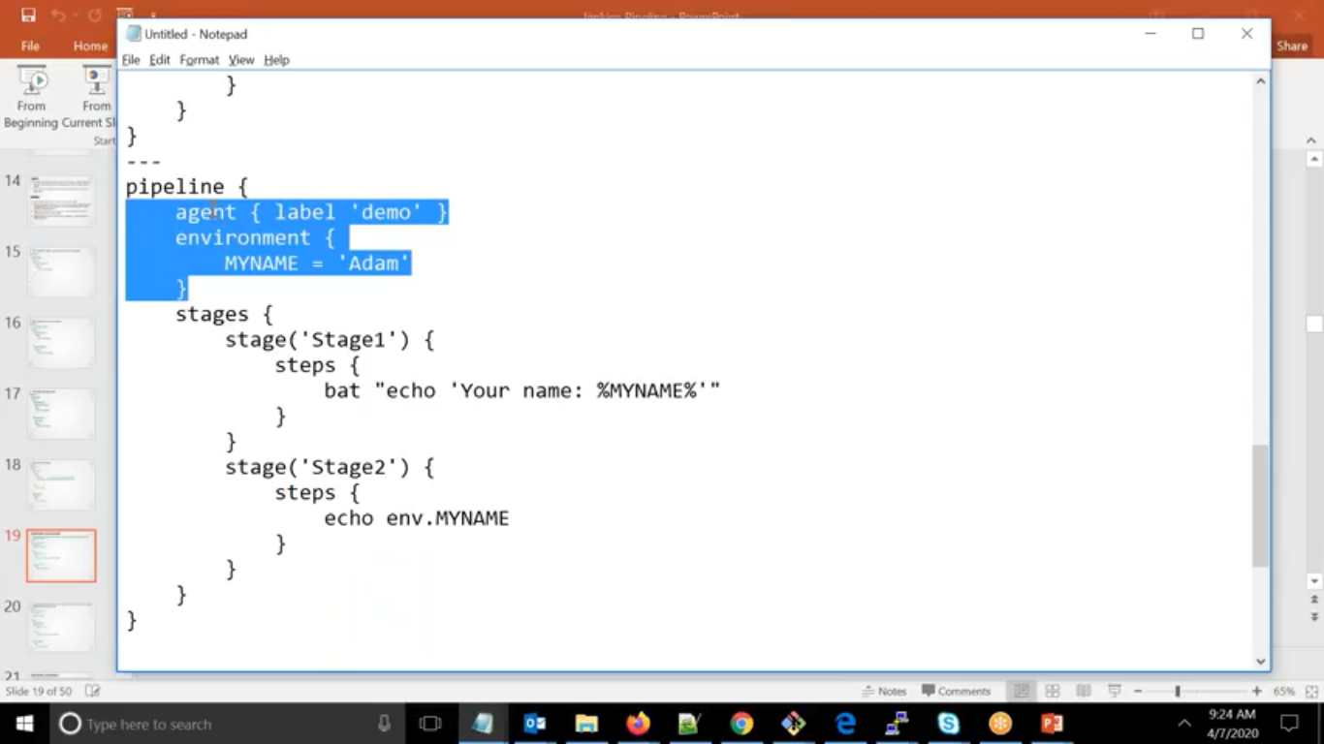

We can pass environment variable as well as above

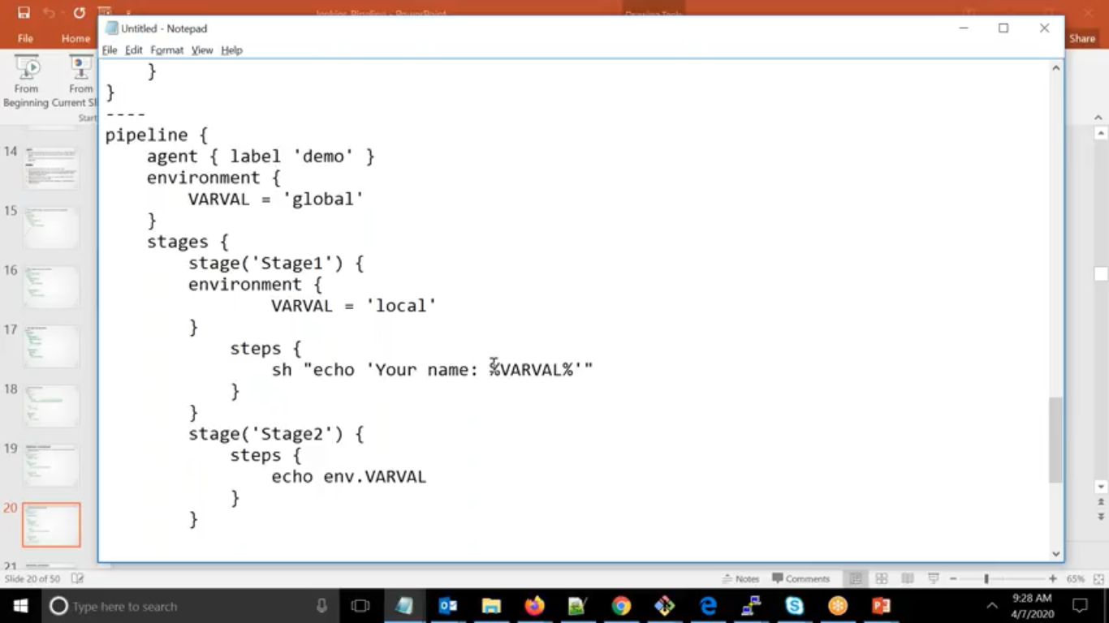

If you want for specific stages then local env variable

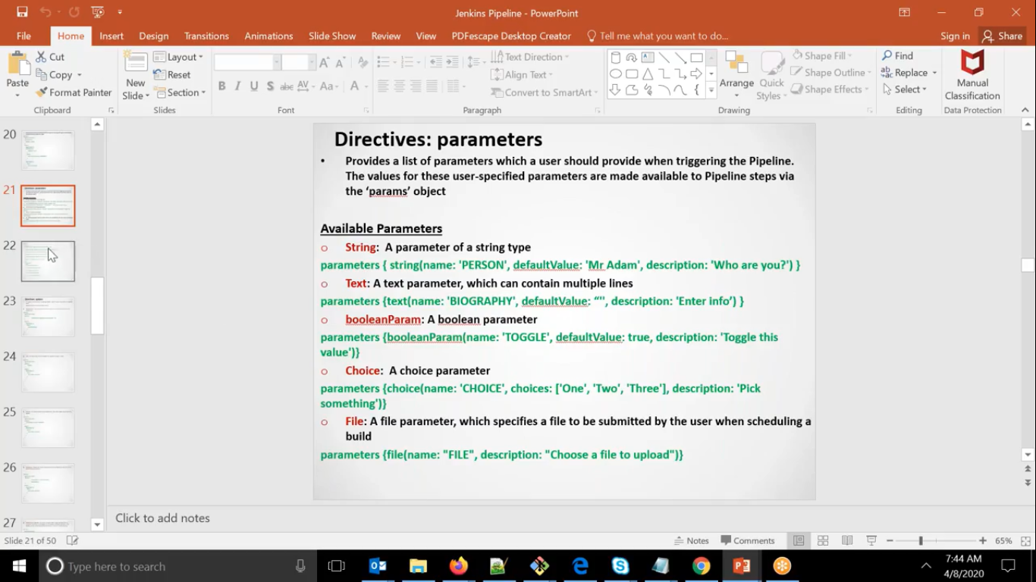

Here Each block is called as directive

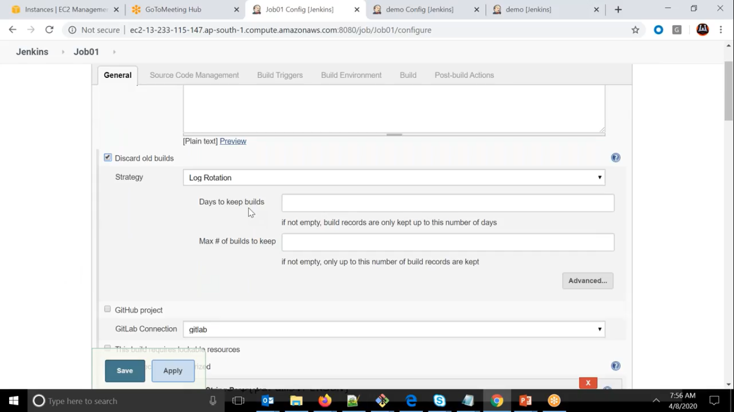

We can discard old builds as well

Similarly, via pipeline also we can do

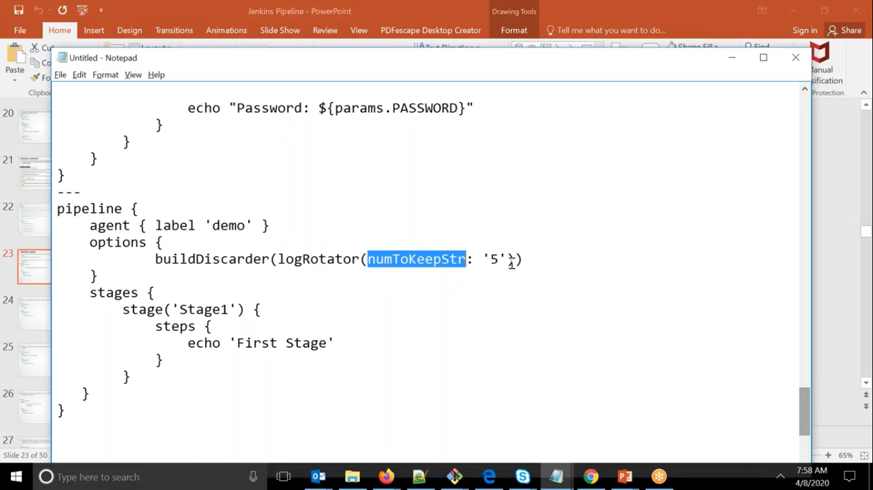

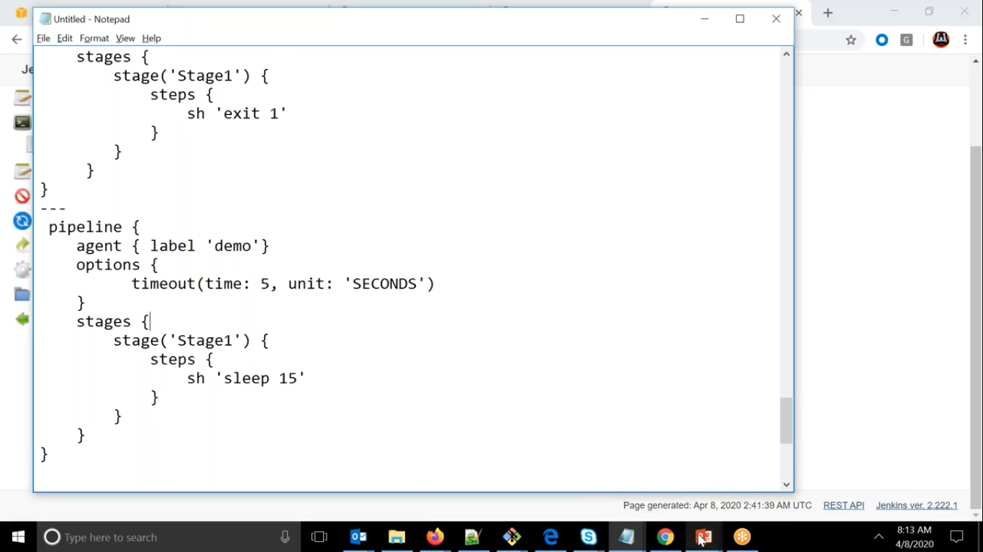

We can do timeout and abort the task in between

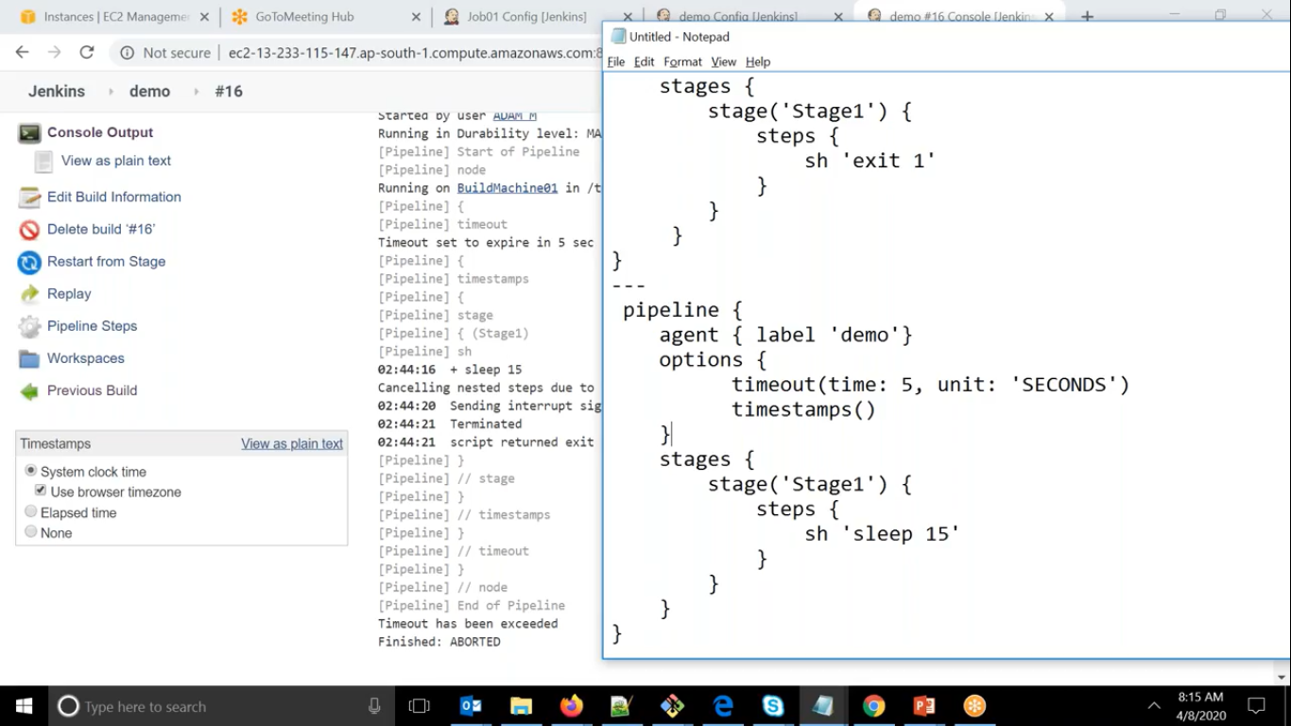If we want to know the time when it starts then we can use timestamps( )

Sometime if you do not want one build to run more than once at a time.

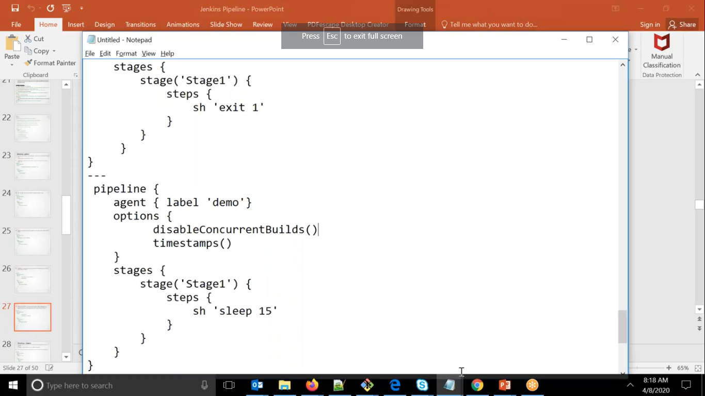

We can do this via using disableConcurrentBuilds

SO that if we try to run more than once it will tell its already in queqe

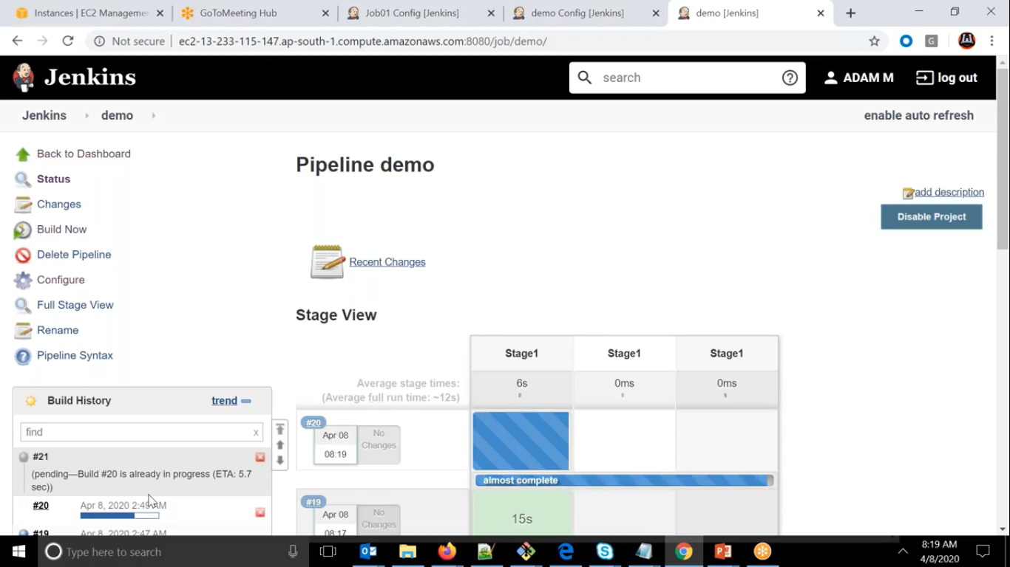

If we want triggers in pipeline we can do by triggers

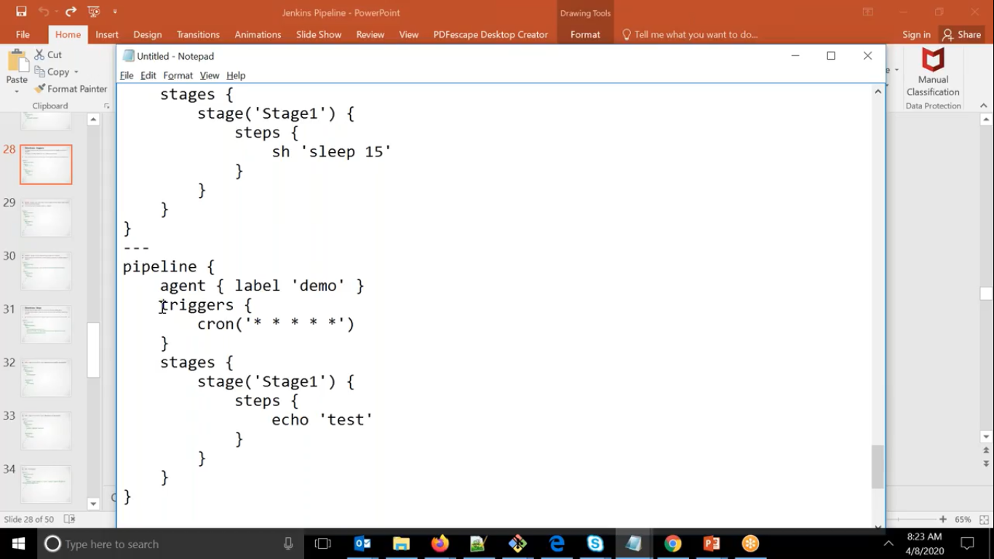

Here it will get triggered after every one minute

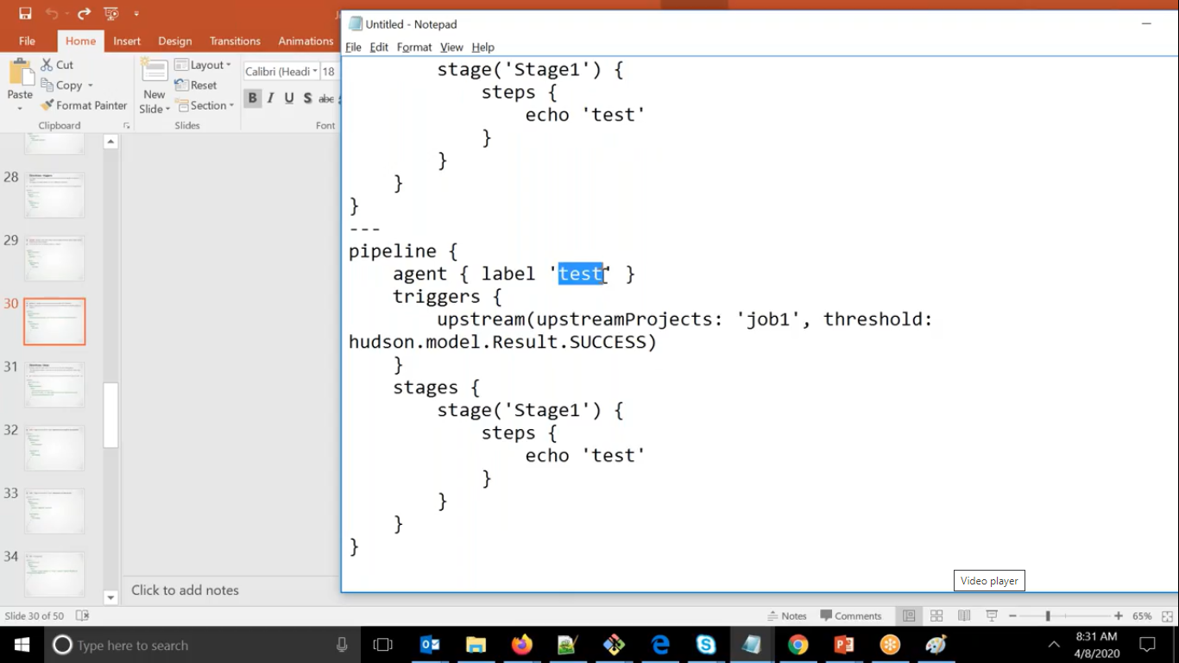

If want to check either up job is run or not

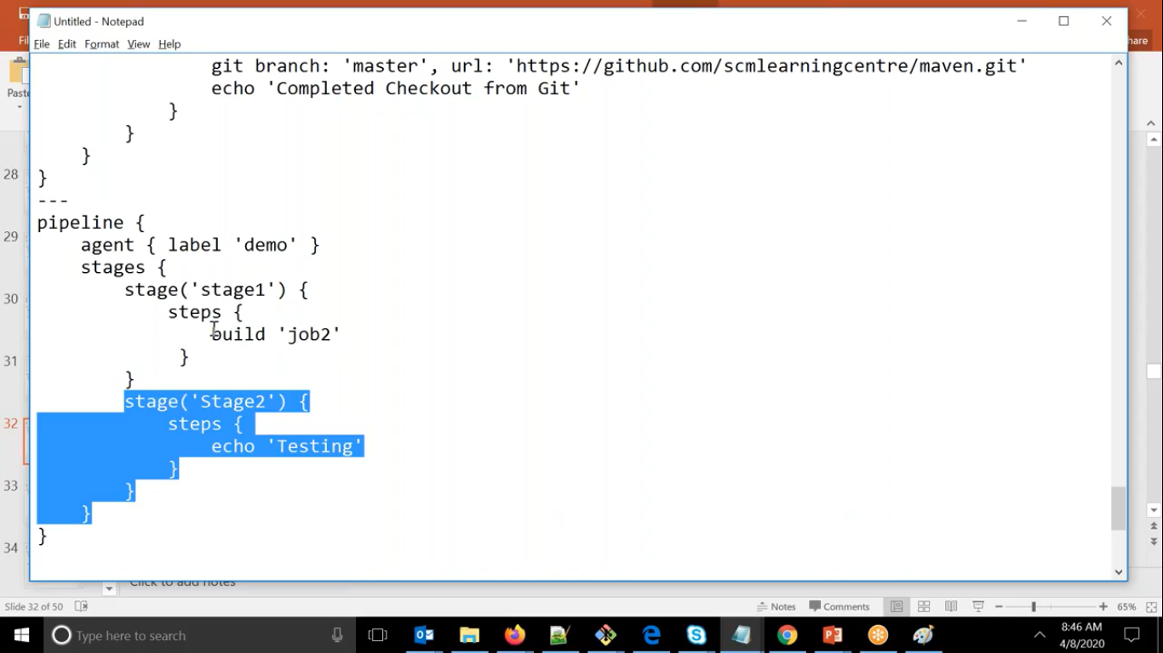

If we want to call another job from existing job

If you don’t want existing job to wait then we can do it via wait : false

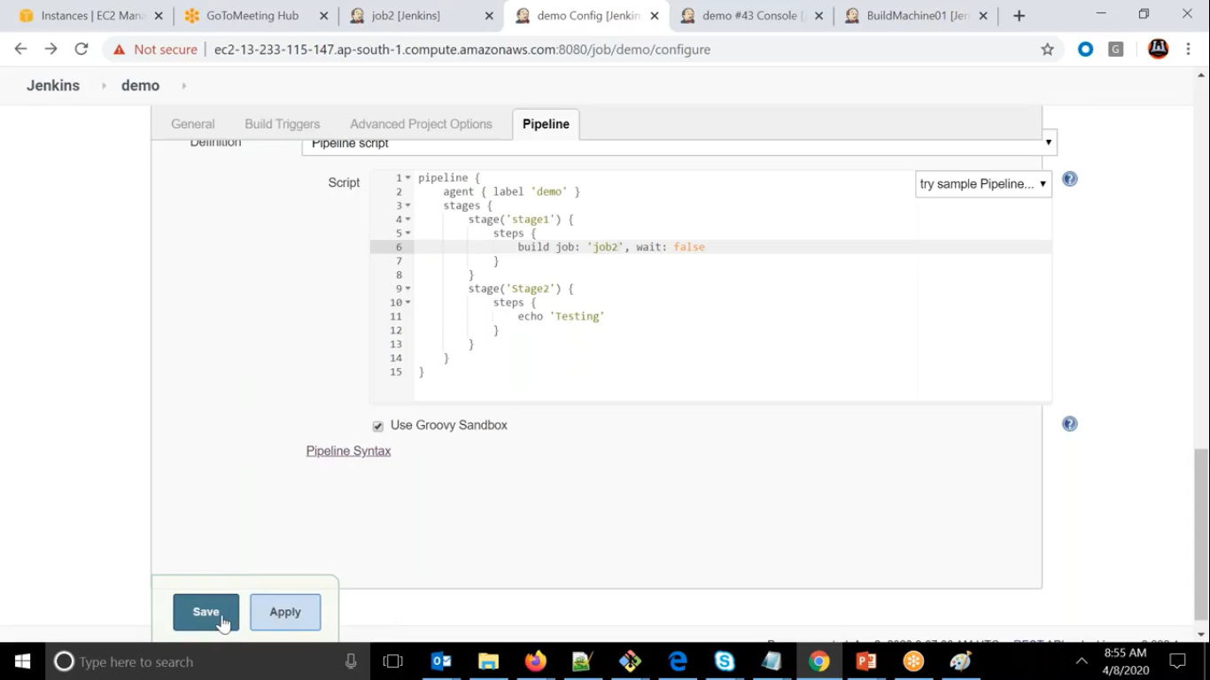

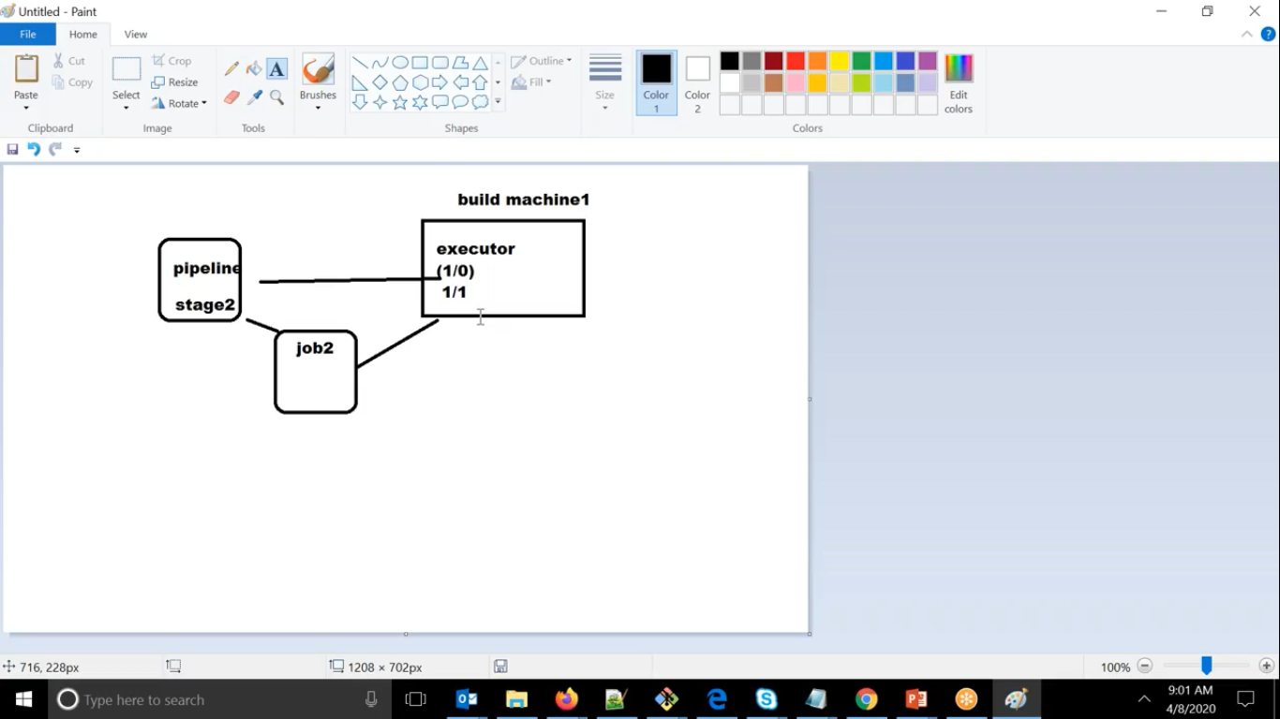

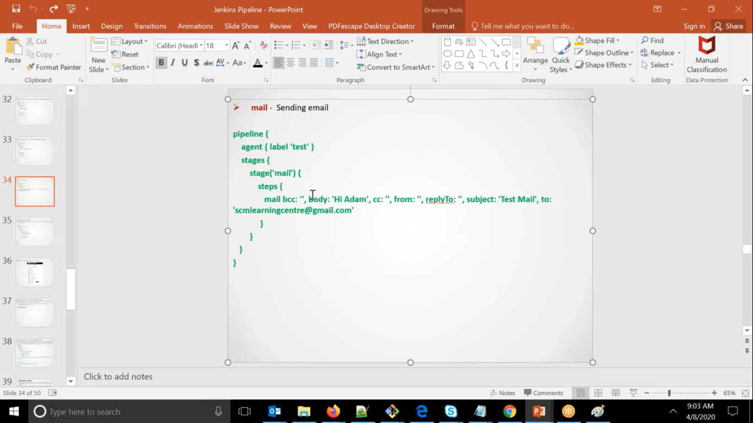

If we want to perform the steps other than default workspace

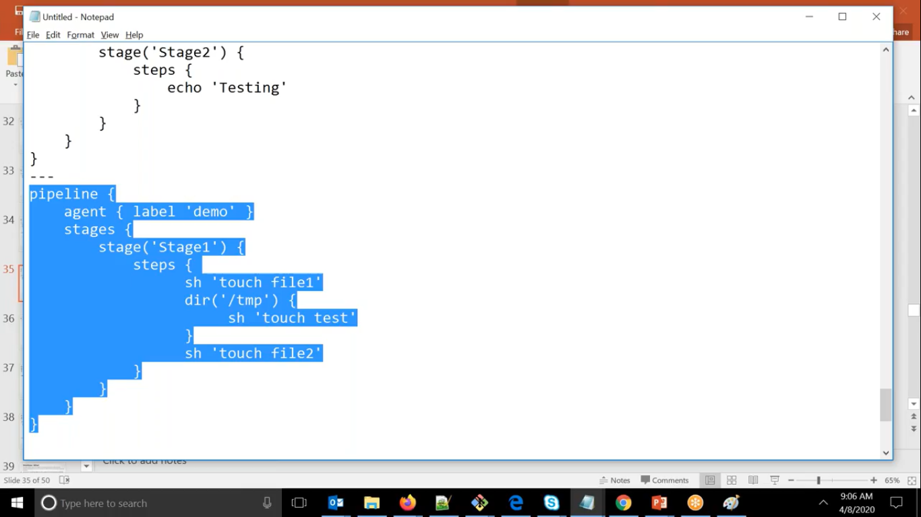

Here in all pipeline we are seeing that we are running the stages blindly without any condition

If we want stages to run based on condition then we can use **when**

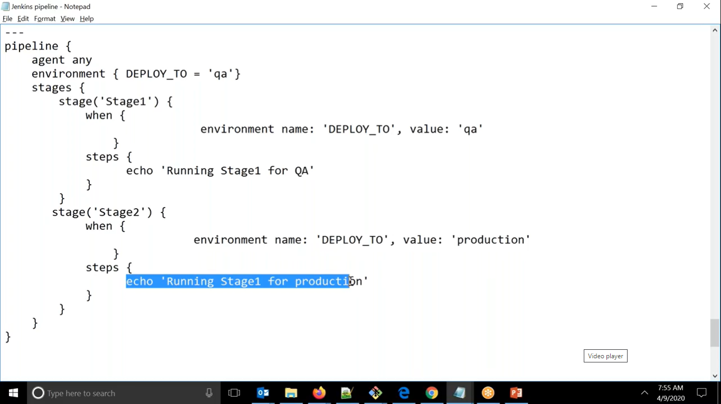  
We can use booleanParams also.

Here since it is true or false so using expression

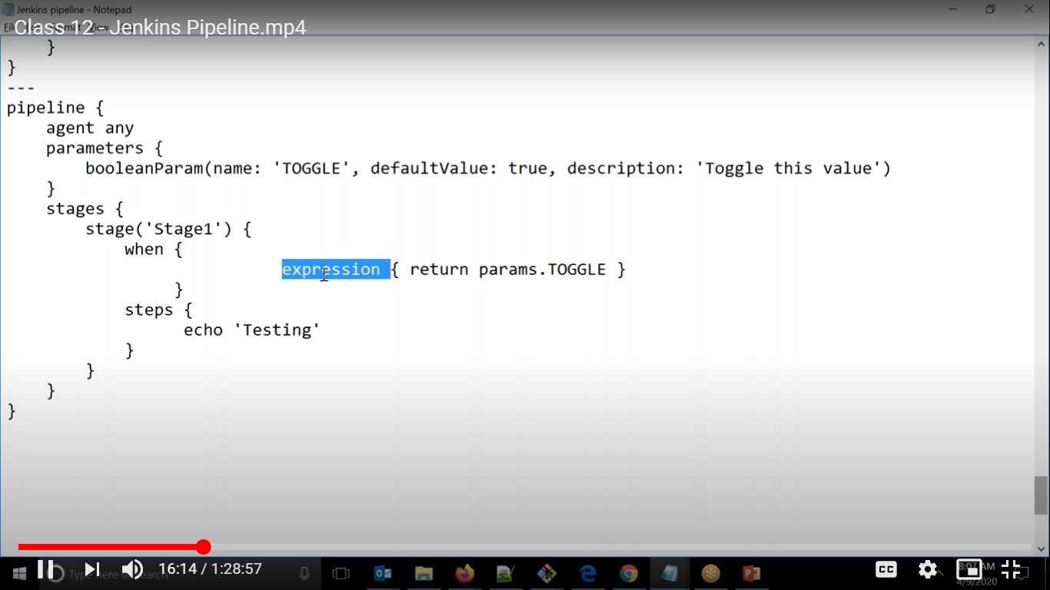

We can check the string conditions as well

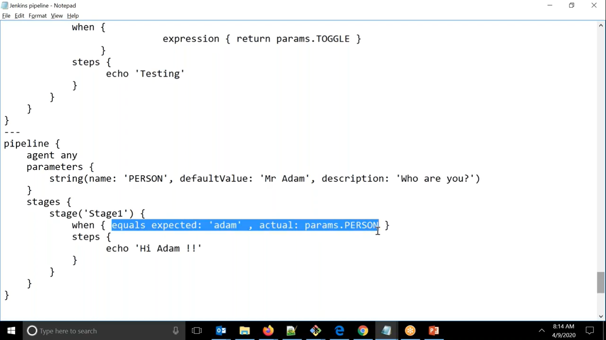

We can use Boolean values also

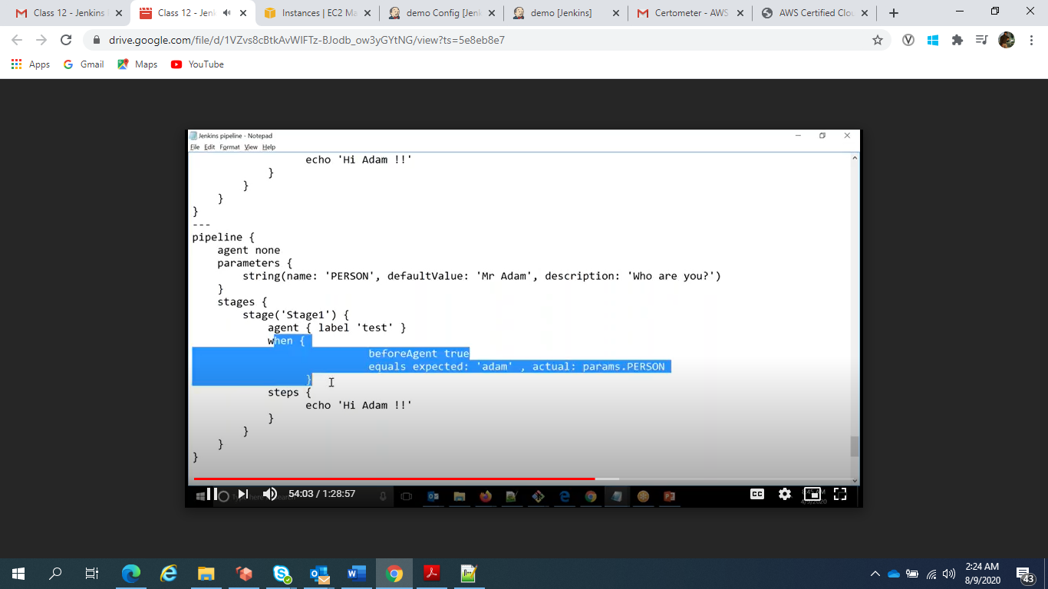

We can execute the stages parallelly

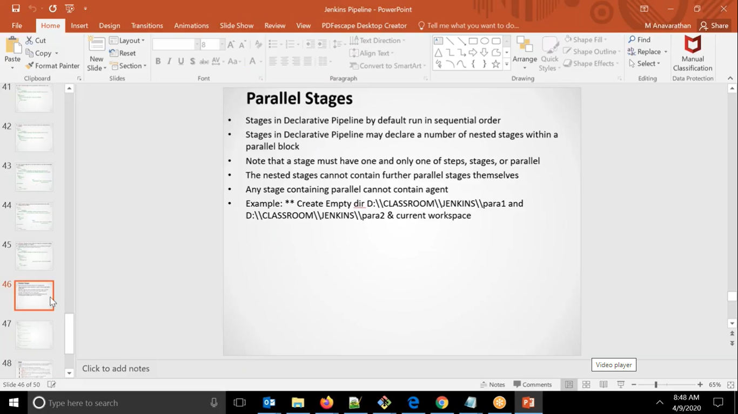

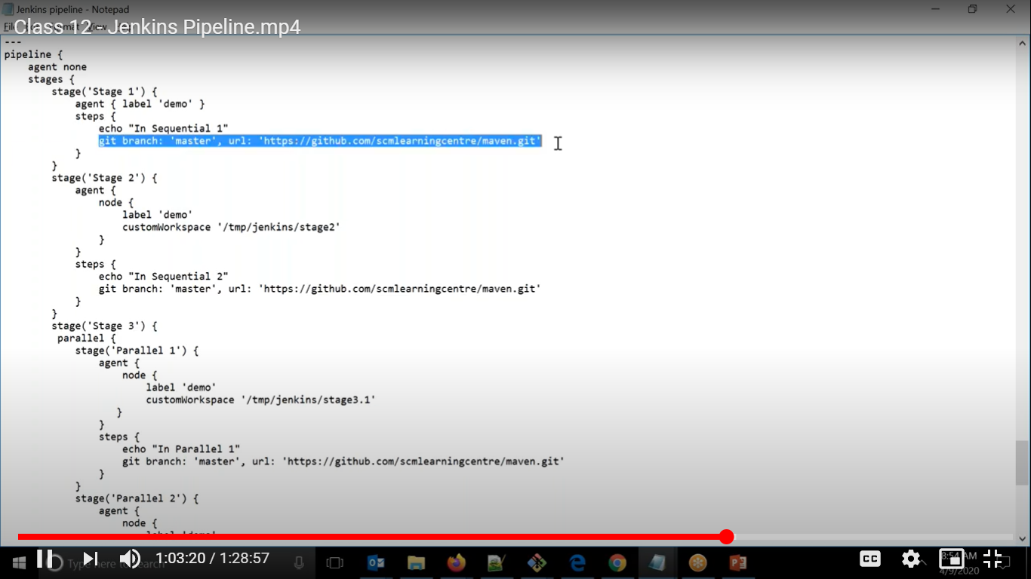

We cannot have parallel block inside parallel block

